# COMPUTER NETWORKS LAB

### [Assignment 8](http://moodlebppimt.ddns.net/course/view.php?id=2254" \l "section-8)

[Stop and Wait](http://moodlebppimt.ddns.net/mod/assign/view.php?id=33029)

1. code:->

//SENDER//

import java.io.*;

import java.net.*;

import java.util.Scanner;

class stopwaitsender

{

public static void main(String args[]) throws Exception

{

stopwaitsender sws = new stopwaitsender();

sws.run();

}

public void run() throws Exception

{

Scanner sc=new Scanner(System.in);

System.out.println("Enter no of frames to be sent:");

int n=sc.nextInt();

Socket myskt=new Socket("localhost",9999);

PrintStream myps=new PrintStream(myskt.getOutputStream());

for(int i=0;i<=n;)

{

if(i==n)

{

myps.println("exit");

break;

}

System.out.println("Frame no "+i+" is sent");

myps.println(i);

BufferedReader bf=new BufferedReader(new InputStreamReader(myskt.getInputStream()));

String ack=bf.readLine();

if(ack!=null)

{

System.out.println("Acknowledgement was Received from receiver");

i++;

Thread.sleep(4000);

}

else

{

myps.println(i);

}

}

}

}

1. code:->

//RECEIVER//

import java.io.*;

import java.net.*;

class stopwaitreceiver

{

public static void main(String args[])throws Exception

{

stopwaitreceiver swr = new stopwaitreceiver();

swr.run();

}

public void run() throws Exception

{

String temp="any message",str="exit";

ServerSocket myss=new ServerSocket(9999);

Socket ss_accept=myss.accept();

BufferedReader ss_bf=new BufferedReader(new InputStreamReader(ss_accept.getInputStream()));

PrintStream myps=new PrintStream(ss_accept.getOutputStream());

while(temp.compareTo(str)!=0)

{

Thread.sleep(1000);

temp=ss_bf.readLine();

if(temp.compareTo(str)==0)

{ break;}

System.out.println("Frame "+temp+" was received");

Thread.sleep(500);

myps.println("Received");

}

System.out.println("ALL FRAMES WERE RECEIVED SUCCESSFULLY");

}

}

**OUTPUT FOR SENDER:**

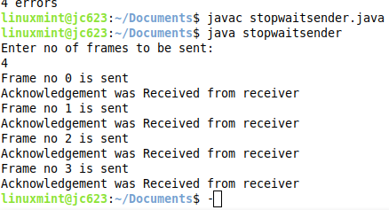

**OUTPUT FOR RECEIVER:**

